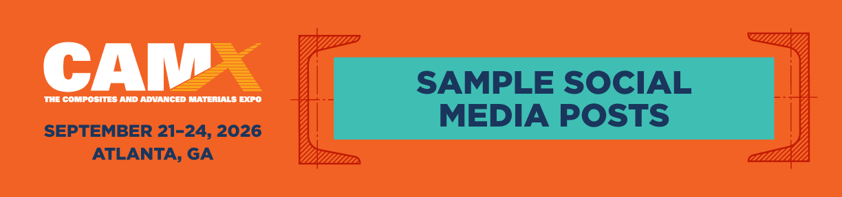

Adjust this copy as needed, and add it to blog posts, newsletters, social media, and in any other media you may use to communicate with your customers.

SAMPLE BLOG POST
CAMX 2026 is where the composites and advanced materials industry comes together to move from innovation to real-world application. As the largest, most comprehensive event in North America, CAMX brings engineers, manufacturers, OEMs, and business leaders together to explore solutions that drive production, performance, and profitability.
We’ll be there September 21–24 in Atlanta, GA at booth [INSERT BOOTH NUMBER], showcasing [INSERT YOUR FEATURED PRODUCT/MATERIAL/SERVICE]. Make plans to stop by, see what’s new, and talk with our team about how we can support your next phase of growth.
Register now at TheCAMX.org/Register. We look forward to seeing you at CAMX, where materials shape the markets.

SAMPLE TWEETS & FACEBOOK POSTS
(Use hashtag #CAMX2026)
• Where materials shape the markets. Visit us at #CAMX2026—Booth XXXXX.
• We’re exhibiting at CAMX 2026. Let’s connect in Atlanta. Booth XXXXX.
• From innovation to production—discover what’s next for your business. Booth XXXXX at #CAMX2026.
• CAMX 2026 is almost here. We’ll be on the show floor at booth XXXXX. Let’s talk!
• This is where materials become market-ready solutions. Join us at CAMX 2026. Booth XXXXX.
• See it. Evaluate it. Talk to the team. Get hands-on with [PRODUCT] at booth XXXXX during #CAMX2026.
• Real conversations. Practical solutions. Meet us at booth XXXXX at #CAMX2026.
• Registration is open! Join us at CAMX 2026 and visit booth XXXXX. TheCAMX.org/Register #CAMX2026
• We’re live at CAMX 2026! Stop by booth XXXXX to connect with our team. #CAMX2026

EMAIL SIGNATURE LINE
(Add this message to your outgoing email signature line)
Join us at CAMX 2026, September 21–24 in Atlanta, GA. Register today at TheCAMX.org/Register and visit us at booth XXXX.

