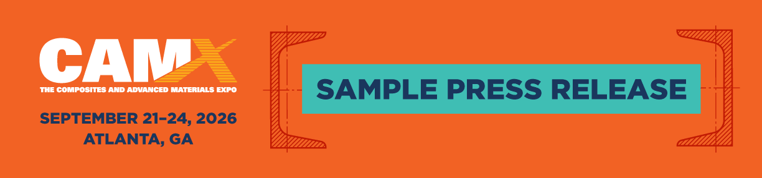

Use this sample press release as a guide to announce the products and services you will be featuring at CAMX 2026.

For Immediate Release Contact: [NAME]
[INSERT TODAY’S DATE] 555-555-5555

[INSERT COMPANY NAME] to Exhibit
at CAMX 2026 in Atlanta with Hundreds of Composite Leaders

YOUR CITY [INSERT DATE, e.g., June 1, 2026] — [INSERT COMPANY NAME] will exhibit at CAMX 2026, taking place September 21–24 in Atlanta, GA.
As the largest, most comprehensive composites and advanced materials event in North America, CAMX brings together hundreds of exhibitors and thousands of engineers, manufacturers, OEMs, and business leaders focused on turning innovation into real-world production and market-ready solutions.
This year, [Company Name] will showcase [brief description of what you're featuring] at booth [Your Booth Number].
“CAMX is where all the latest composite innovation and research becomes applicable to real-world business scenarios,” said [Full Name, Title at Company]. “It’s an opportunity to connect directly with customers, engage with new prospects, and demonstrate how our latest solutions support real business needs.”
In addition to hands-on demonstrations, booth visitors can experience [insert key experience or offering—e.g., “live product demos,” “engineering consultations,” or “application-specific walkthroughs”]. The [Company Name] team will be available throughout the event to discuss solutions that support performance, scalability, and efficiency across a range of industries.
To learn more about [Company Name] and its presence at CAMX 2026, visit [website URL] or connect with the team onsite.
CAMX is produced by the American Composites Manufacturers Association (ACMA) and The Society for the Advancement of Material and Process Engineering (SAMPE), and brings together the global composites and advanced materials community for four days of education, networking, and business development.
[INSERT YOUR COMPANY’S INFORMATION, INCLUDING LOCATION, OWNERS, AND DESCRIPTION OF PRODUCTS/SERVICES].

# # #

