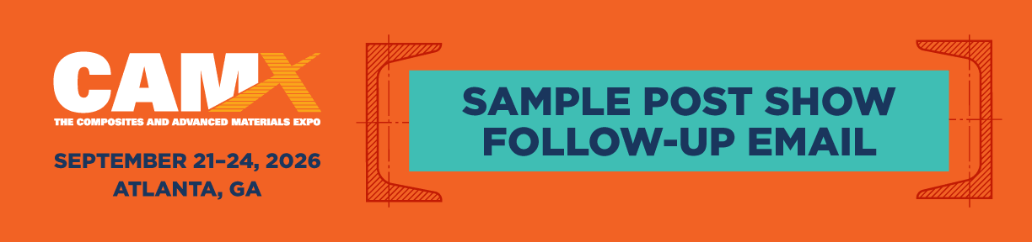

Within two weeks following CAMX 2026, send personalized thank-you messages to the customers and new contacts who visited your booth. This is an opportunity to reinforce key conversations, highlight relevant solutions, and continue building momentum after the show.

Dear [INSERT NAME],
It was great connecting with you at CAMX 2026. We appreciated the opportunity to learn more about [CUSTOMER COMPANY NAME] and the challenges you're working to solve.
CAMX is where materials shape the markets, and we’re excited about the opportunity to continue that momentum with you. Following the show, our team has been reviewing how we can best support your goals. Based on our conversation, we believe [PRODUCT/SERVICE] can deliver value by helping you [INSERT KEY BENEFIT OR PAIN POINT SOLVED].
Below are a few resources to support your next steps:
[INSERT BULLETED LIST OF YOUR WEB PAGES, PRODUCT/SERVICE VIDEOS, BLOG ARTICLES, TESTIMONIALS, CASE STUDIES, ETC.]
If you have any questions or would like to explore this further, I’d be happy to connect. I’ll follow up soon, but feel free to reach out anytime.
Looking forward to continuing the conversation,
[NAME]
[YOUR COMPANY NAME]

