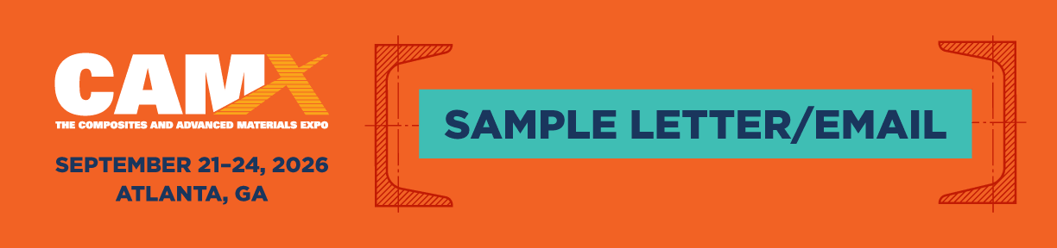

Promote your company’s booth at CAMX 2026 by sending an email or letter to current and potential clients. Your outreach efforts are important, so please send this invitation to anyone who may benefit from attending. To get started, try this sample copy (it’s easily customizable)!

Recommended Subject Lines:
- Let’s Meet at CAMX 2026 — Booth [####]
- Where Materials Shape the Markets — Join Us at CAMX
- Heading to CAMX? Don’t Miss This Booth
- Make Your CAMX Experience Count — Visit Us in Atlanta

Recommended Body Content:
Dear [INSERT CUSTOMER NAME],
We’re heading to Atlanta this September for CAMX 2026 and we’d love to see you there. As the largest, most comprehensive composites and advanced materials event in North America, CAMX brings together engineers, manufacturers, OEMs, and business leaders focused on turning innovation into real-world production and business results. If you’re looking for new materials, stronger partnerships, and practical solutions, this is where it all comes together.
Here’s what makes CAMX worth the trip:
Discover what’s next and what’s ready now.
With hundreds of exhibitors across the show floor, CAMX is where new materials, processes, and technologies are introduced and where production-ready solutions can be evaluated side by side.
Strengthen your supply chain.
The right conversations can move your business forward. Connect with current suppliers, discover new partners, and explore solutions that support scalability, performance, and cost efficiency.
Stay ahead of the curve.
From emerging applications to evolving manufacturing techniques, CAMX puts you at the center of what’s shaping the industry. Gain insights that help you make smarter, more informed decisions.
Learn, grow, and connect.
CAMX offers the most comprehensive education program in the industry, with sessions designed to deliver practical takeaways you can apply immediately.
Find solutions that support real-world production.
Explore materials and technologies designed for durability, efficiency, and scalability across industries, from aerospace and automotive to construction and infrastructure.
[INSERT YOUR COMPANY NAME] will be at booth [####], showcasing [PRODUCT/SERVICE] that will [INSERT VALUE OR BENEFIT]. Stop by to see it in action, ask questions, and talk with our team about how we can support your goals. We’re ready to help you make the most of your time at CAMX, where materials shape the markets.
See you in Atlanta,
[NAME]
[YOUR COMPANY NAME]
Register now at TheCAMX.org/Register

